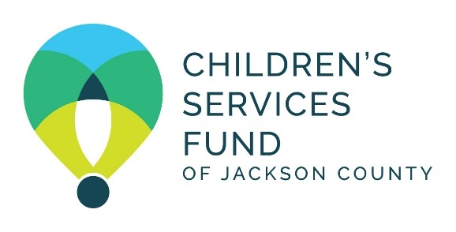

Children’s Services Fund of Jackson County

2:30 pm, October 17, 2024
CSF Community Room
- Grand Blvd, 14th Floor, Kansas City, MO 64108

2:30 Call to Order, Roll Call and Guest Introductions - Jessica Ramirez, Board Chair

2:35 Review/Approval - Jessica Ramirez, Board Chair
- BOD Meeting Minutes – September 19, 2024– Action Needed
- Proposed Agenda

2:40 Invest in Children – Jessica Ramirez, Board Chair
      - Financial Update - Ajia Morris, Treasurer/Moji Shogbamimu, Chief Financial Officer
        - September 2024 Financial Activity
        - 2024 Budget Amendment– Action Needed
        - 2025 Budget Projections
        - 2023 Form 990
      - CSF Funding Opportunities - Judy Morgan, External Affairs Chair/ Jovanna Rohs, Chief Program Officer
        - Core Funding: Calendar Year 2025/2026 – Action Needed
        - Cultivation Funding 2025/2026 – Action Needed

3:20 Strengthen Partners - Judy Morgan, External Affairs Chair/Jovanna Rohs, Chief Program Officer
- Spring Site Visits

3:25 Honor Community - Judy Morgan, External Affairs Chair/Rob Whitten, Chief Executive Officer
- Children’s Services Assessment Jane Mosley, Director of Impact

3:30 Optimize Organization – Amy Harris, Internal Affairs Chair/Rob Whitten, Chief Executive Officer
- Organizational Updates
  - Fluxx Software Update Celeste Ortiz, Contract Administrator
  - HR Engagement Rob Whitten, CEO
  - 2024 Conflict of Interest Disclosure Rob Whitten, CEO

3:35 Old/New Business - Jessica Ramirez, Board Chair

3:40 Director and Guest Comments - Jessica Ramirez, Board Chair

3:45 Closed Session – CEO Performance Evaluation, Partner Contracting Issue, Board Composition

4:30 Return to Open Session/Adjournment

Next Meeting: Thursday, November 21, 2024, 2:30 pm
CSF Community Room, 2345 Grand Blvd, 14th Floor, Kansas City, MO 64108

