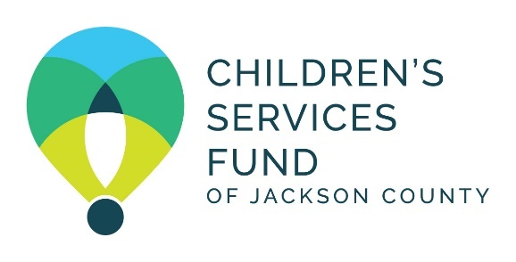

Children’s Services Fund of Jackson County

3:00 pm, April 16,2026
CSF Community Room
- Grand Blvd, 14th Floor, Kansas City, MO 64108

Call to Order, Roll Call, and Guest Introductions - Brian Kaberline, Board Vice Chair

Review/Approval – Brian Kaberline, Board Vice Chair
- BOD Meeting Minutes – February 26,2026 – Action Needed
- Proposed Agenda

Invest in Children – Brian Kaberline, Board Vice Chair
      - Partner Spotlights: Mother’s Refuge, Our Spot KC
      - Financial Update - Moji Shogbamimu, Chief Financial Officer
        - March 2026 Financial Activity
      - CSF Funding – Jovanna Rohs, Chief Program Officer
        - Core Funding: Academic Year Funding Slate – Action Needed
        - Capacity Building Funding Slate – Action Needed
        - CSF Funding: World Cup Trafficking Response – Action Needed

Strengthen Partners – Russell Anderson, Director of Health Equity
- Mental Health Equity Community of Practice

Honor Community – Jane Mosley, Director of Impact
- Center for Effective Philanthropy Survey
- Community Impact Report 2025

Optimize Organization – Rob Whitten, CEO
- Organizational Updates
  - CSF Policy Agenda Areas/Missouri Legislative Update
  - Election of Board Officers
  - Other Updates

Old/New Business - Brian Kaberline, Board Vice Chair

Director Comments - Brian Kaberline, Board Vice Chair

Public Comments (Limited to three minutes each) – Brian Kaberline, Board Vice Chair

Closed Session

Adjournment

Next BOD Meeting: Thursday, June 18, 3:00
CSF Community Room, 2345 Grand Blvd, 14th Floor, Kansas City, MO 64108

